Problem 1:

Create a calculator class with attributes of 2 float variables and 4 methods to add, subtract, multiply, divide and a constructor to take in two floats.

Then create an instance of the class, an object to take in 2 arguments ie. 2 floats input by user.

Code:

#include<iostream>

using namespace std;

class Calc{

private:

float a;

float b;

public:

Calc(float A, float B){

a=A;

b=B;

}

float add(){

return a+b;

}

float subtrac(){

if(a>b)

return a-b;

else

return b-a;

}

float multiply(){

return a\*b;

}

float devide(){

return a/b;

}

};

int main(){

float a,b;

cin>>a>>b;

Calc test1(a,b);

cout<<"Sum = "<<test1.add()<<"\n"<<"Difference = "<<test1.subtrac()<<"\n"<<"Multiple = "<<test1.multiply()<<"\n"<<"Division = "<<test1.devide()<<endl;

return 0;

}

Output:

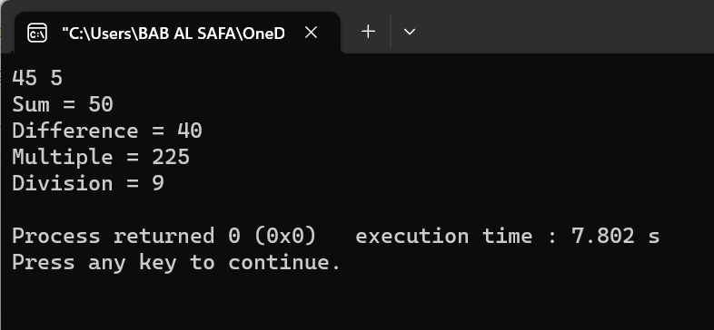

Fig 1: Output on console.

Problem 2:

Create a student class with attributes, char name, int id, char department, and 3 course-gpa and a constructor, and a method to calculate cgpa and print t on console along with his or her information.

Code:

#include<iostream>

#include<string>

using namespace std;

class Student{

private:

string name;

int id;

string dept;

float c1,c2,c3;

public:

Student(string Name, int Id, string Dept, float C1, float C2, float C3){

name=Name;

id=Id;

dept=Dept;

c1=C1;

c2=C2;

c3=C3;

}

float cgpaCalc(){

return (c1+c2+c3)/60;

}

void displayInfo(){

cout<<"Name = "<<name<<"\n"<<"ID = "<<id<<"\n"<<"Dept. = "<<dept<<"\n"<<"cgpa = "<<cgpaCalc()<<endl;

}

};

int main(){

string name;

int id;

string dept;

float c1,c2,c3;

cin>>name>>id>>dept>>c1>>c2>>c3;

Student students(name, id, dept, c1, c2, c3);

students.displayInfo();

return 0;

}

Output:

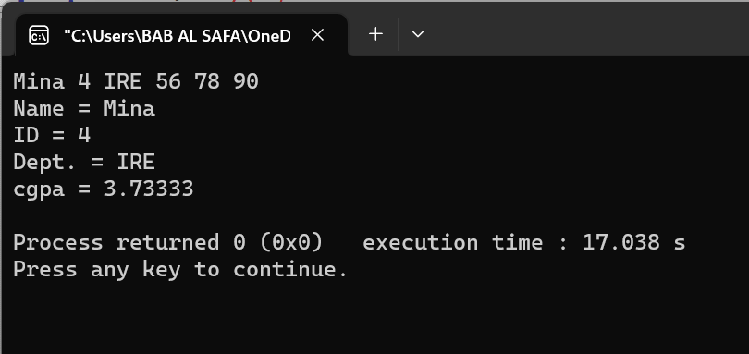

Fig 2: Output on console.